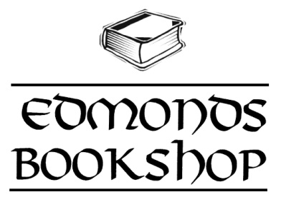  
and



***Present:*** Authors on the Plaza   
at The Edmonds Arts Festival!

|  |  |  |
| --- | --- | --- |
| Friday, June 17th | | |
| 11am | Kizzie Jones | Nicole Chen |
| 12pm | Nova McBee | Wendy Kendall |
| 1pm | Tess Marset | Catherine Alexander |
| 2pm | Erica Miner | Ingrid Wolsk |
| 3pm | Kelly Jones | Laura Moe |
| 4pm | Catherine Linka | Kim Helleren |
| 5pm | Tom Frank | Priscilla Long |
| Saturday, June 18th | | |
| 10am | Judith Works | Richard Taylor |
| 11am | Doug Warren | Paddy Eger |
| 12pm | Brad Holden | Rachel Gardner |
| 1pm | Chamroeun Pen | Kira Jane Buxton |
| 2pm | Naomi Wark | Mimzi Schradi |
| 3pm | Jeffrey Briggs | Terry Woods |
| 4pm | Anna Dahland | Gerald Bigelow |
| 5pm | Valerie Ramer |  |
| Sunday, June 19th | | |
| 12pm | Alan Hardwick |  |
| 1pm | Stacy Flood |  |
| 2pm | Harriet Cannon | Kathleen Glassburn |
| 3pm | Roxanne Dunn |  |

*\*schedule subject to change. This is our best information to date.*